Task 7
import java.io.*;
import java.util.*;

class Result {

public static int diagonalDifference(List<List<Integer>> arr) {

int n = arr.size();
int primary = 0;
int secondary = 0;

for (int i = 0; i < n; i++) {
primary += arr.get(i).get(i);
secondary += arr.get(i).get(n - 1 - i);
}

return Math.abs(primary - secondary);
}
}

public class Solution {

public static void main(String[] args) throws IOException {

BufferedReader br =
new BufferedReader(new InputStreamReader(System.in));

int n = Integer.parseInt(br.readLine().trim());

List<List<Integer>> arr = new ArrayList<>();

for (int i = 0; i < n; i++) {

String[] input = br.readLine().trim().split(" ");

List<Integer> row = new ArrayList<>();

for (int j = 0; j < n; j++) {
row.add(Integer.parseInt(input[j]));
}

arr.add(row);
}

int result = Result.diagonalDifference(arr);

System.out.println(result);
}
}
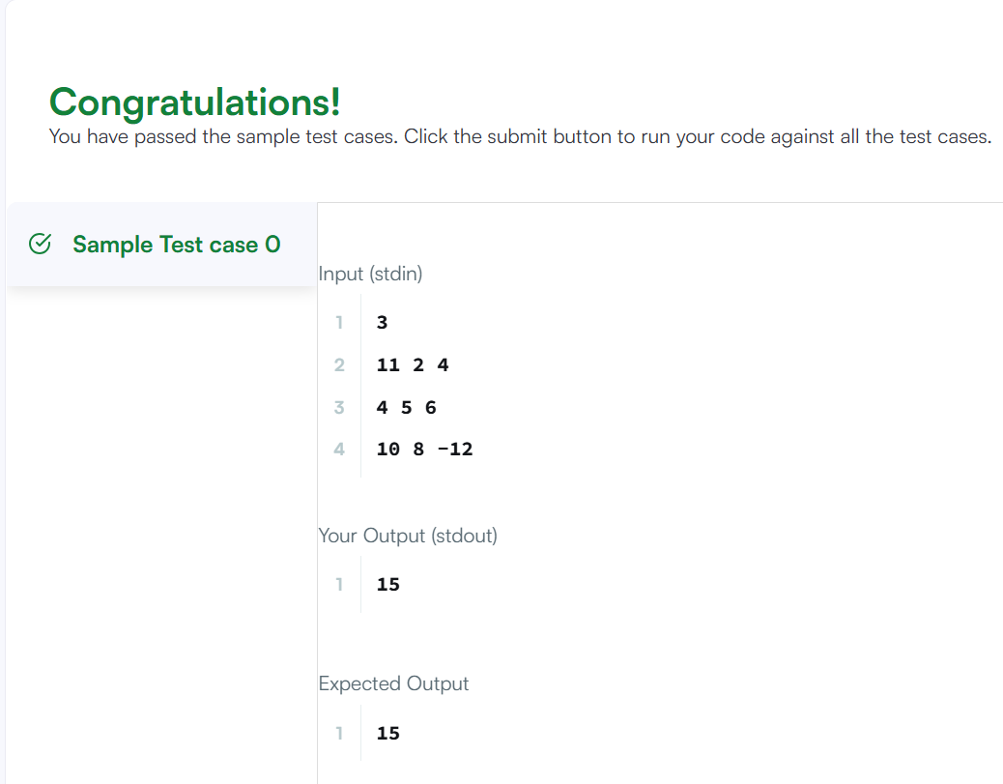
Task 8
class Solution {
public int[][] transpose(int[][] matrix) {

int rows = matrix.length;
int cols = matrix[0].length;

int[][] result = new int[cols][rows];

for (int i = 0; i < rows; i++) {
for (int j = 0; j < cols; j++) {

result[j][i] = matrix[i][j];

}
}

return result;
}
}
